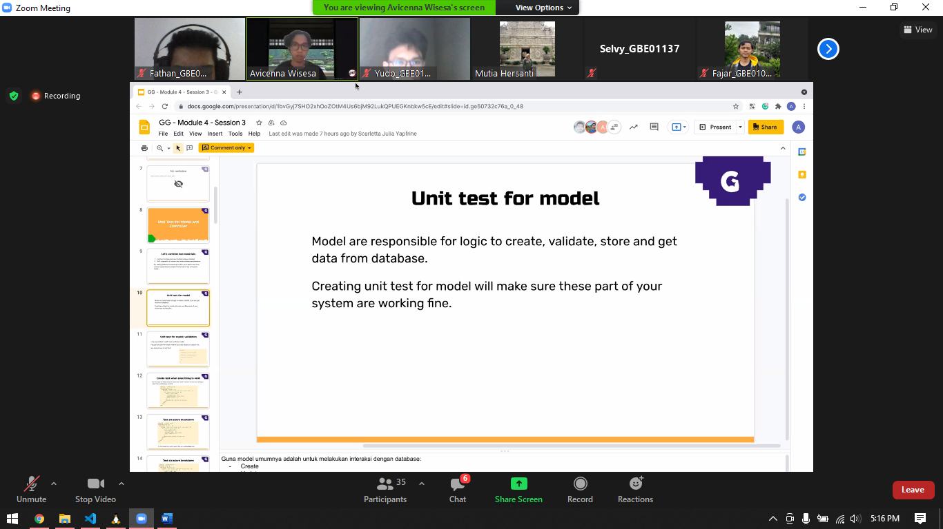

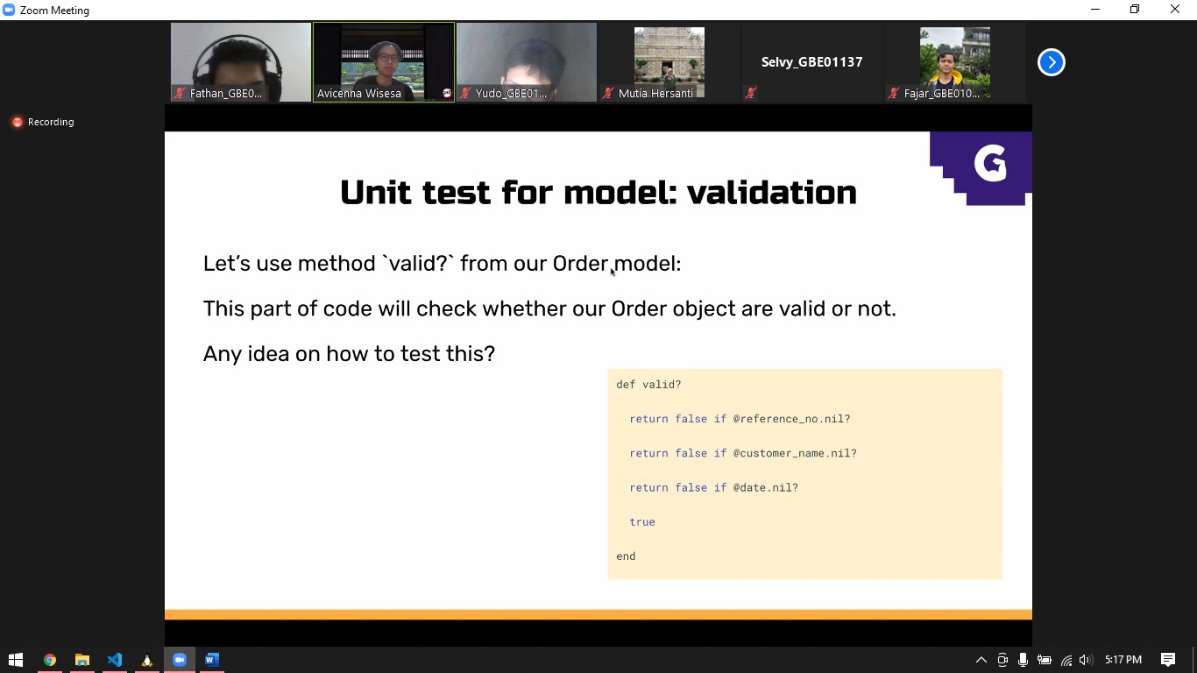

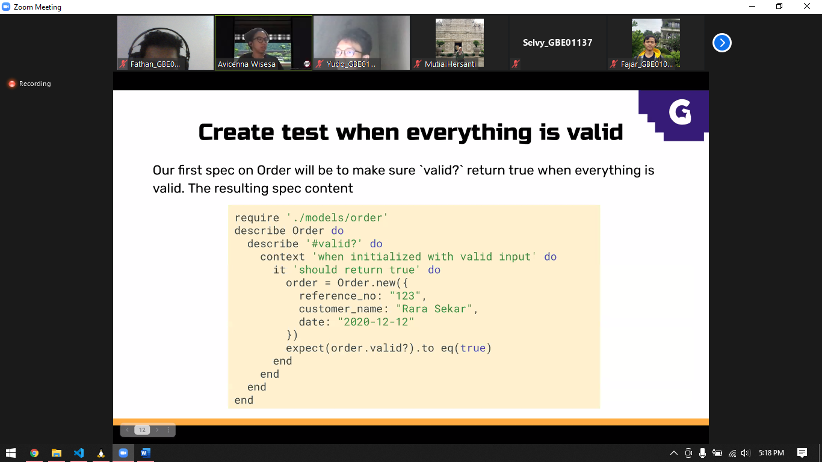

Describe order, order is class

#valid is function in order, so it’s isolated

Context “balabla” do, blalblala means our expectation, it might be concept. It’s like if

It ‘x’ do x same like blabla. And this is then do this

